**Module-3: Dashboard Assignment 4**

**Problem Statement:**

You work for XYZ Corporation, to maintain the security of the AWS Account and the resources you have been asked to implement a solution that can help easily recognize and monitor the different users. Also, you have Will be monitoring the machines created by these users for any errors or misconfigurations.

**You have been asked to:**

**1.** Create a dashboard which lets to check the CPU Utilization and NetworkIn for a particular EC2 instance.

**Problem 1 Solution:**

**1. Create an EC2 Instance**

**Step 1: Click** onthe **“EC2”** in **the “AWS Console Home”.**

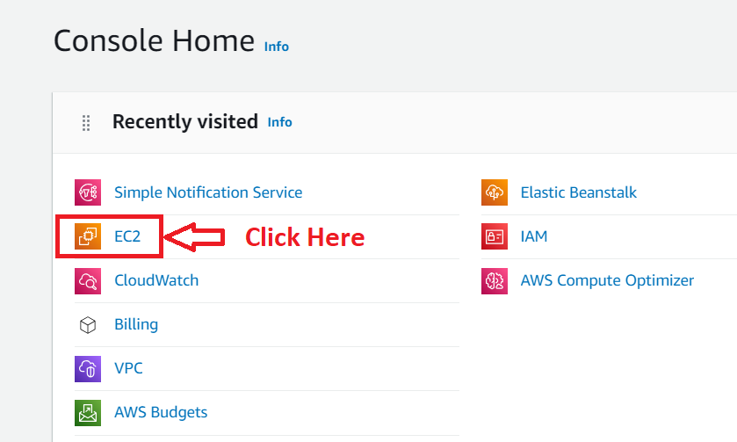

**Step 2: Click** onthe **“Launch Instance”.**

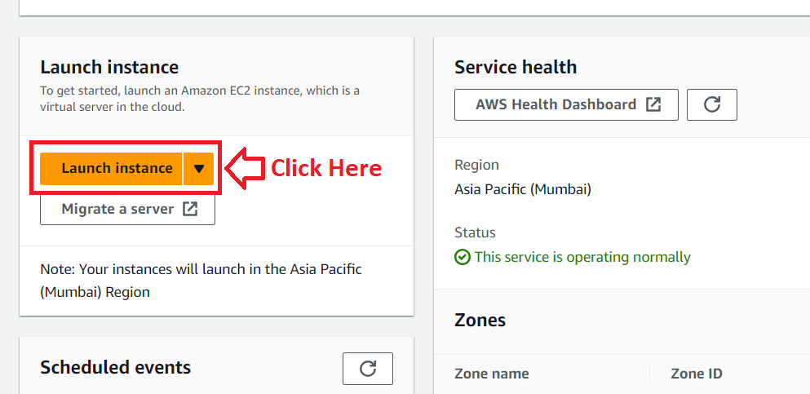

**Step 3: Choose** the **“Instance name”** as **“IAM Dashboard EC2”** inthe **“Name”** under the **“Name and tags”** section**.**

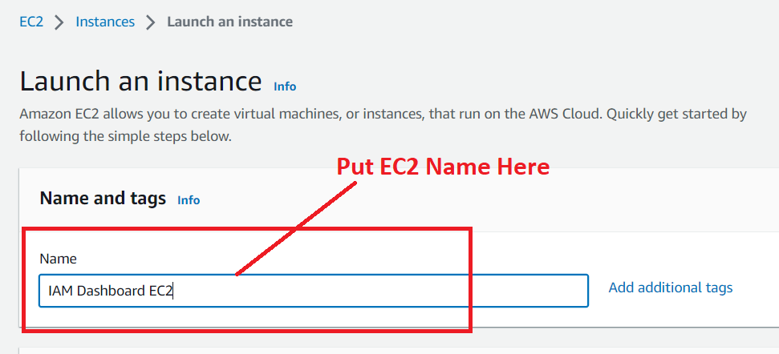

**Step 4: Choose** the **“AMI”** asthe **“Amazon Linux (aws)”.**

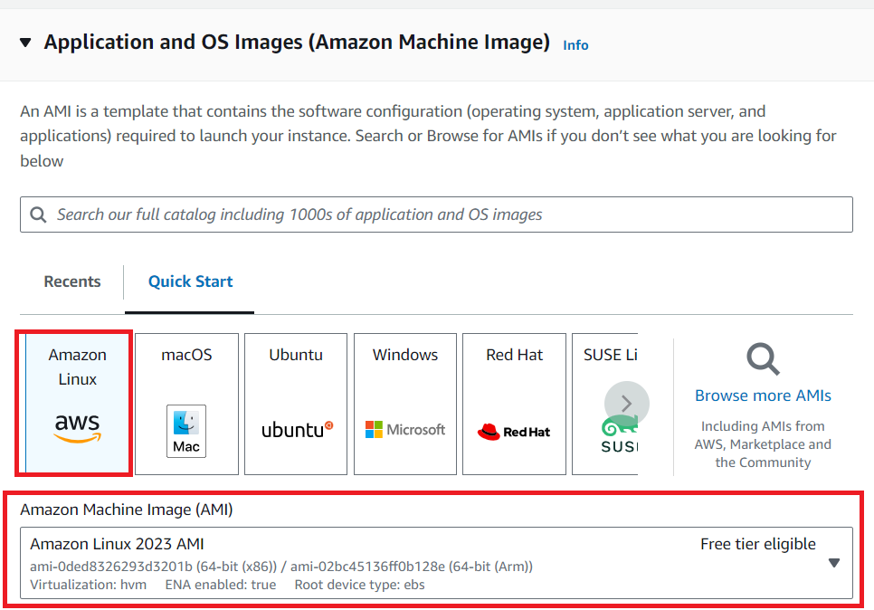

**Step 5: Choose** the **“Instance type”** as **“t2.micro”** & **the “Key pair (login)”** asthe **“Proceed without a key pair (Not recommended).**

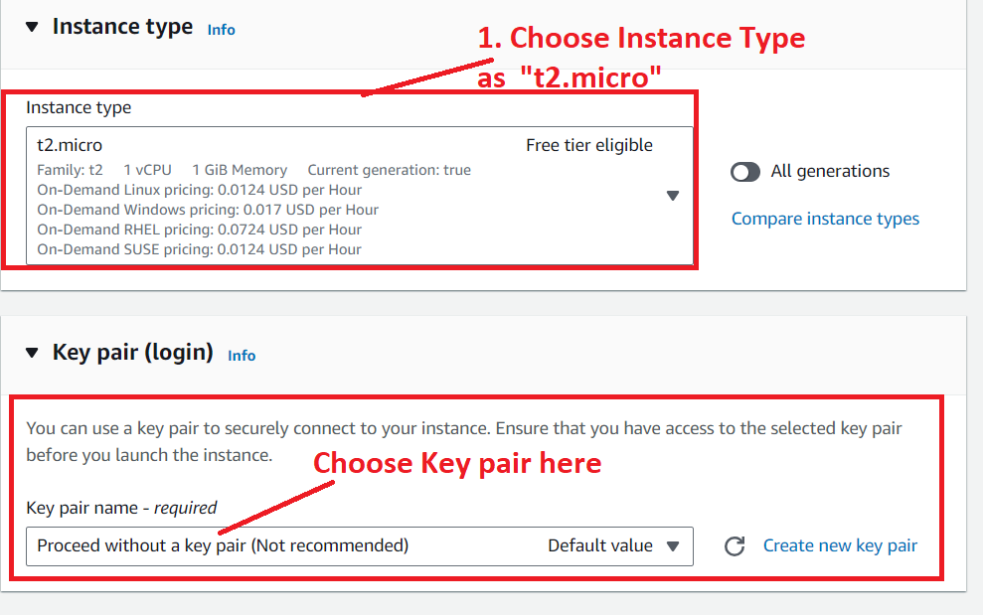

**Step 6: Choose** the **“Allow Traffic from the Internet”** in the **“Network Settings”. Leave** the **other settings** as **by default** in the **“Network Settings” &** the **“Configure Storage”.**

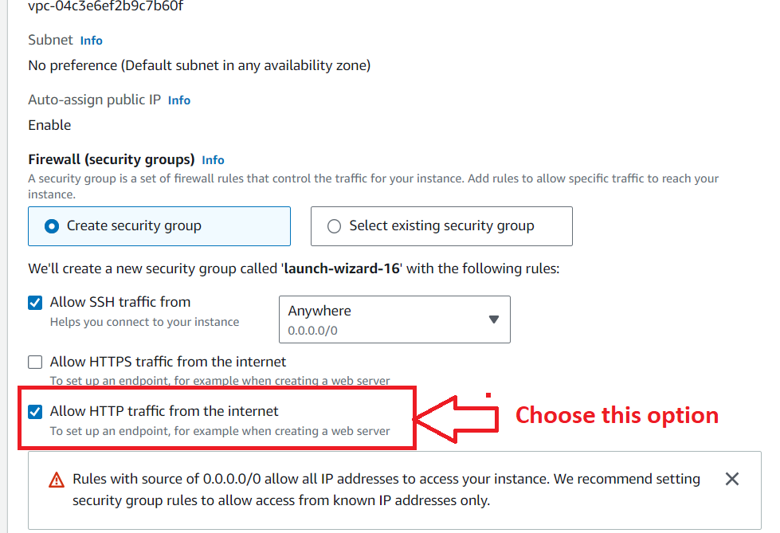

**Step 7: Click** on the **“Launch Instance”.**

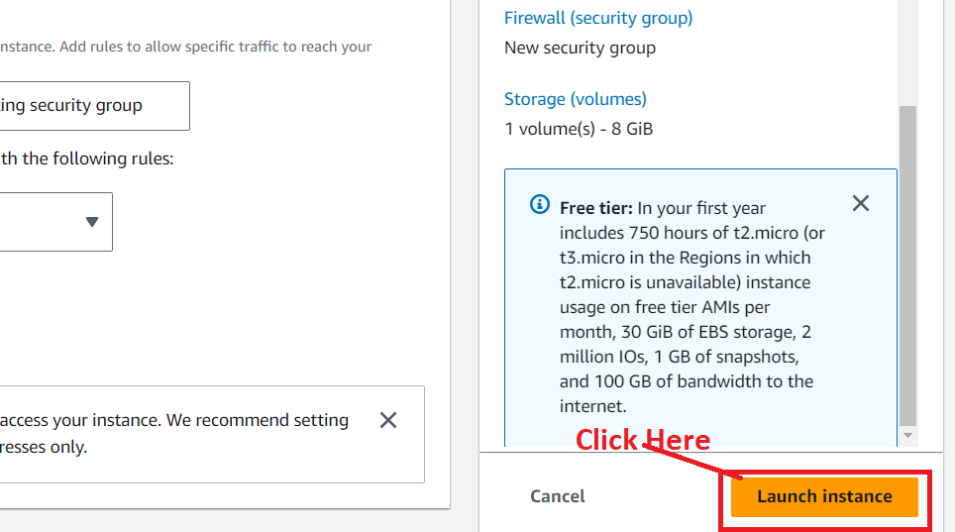

**Step 8: Your EC2 Instance** will be **successfully launched.**

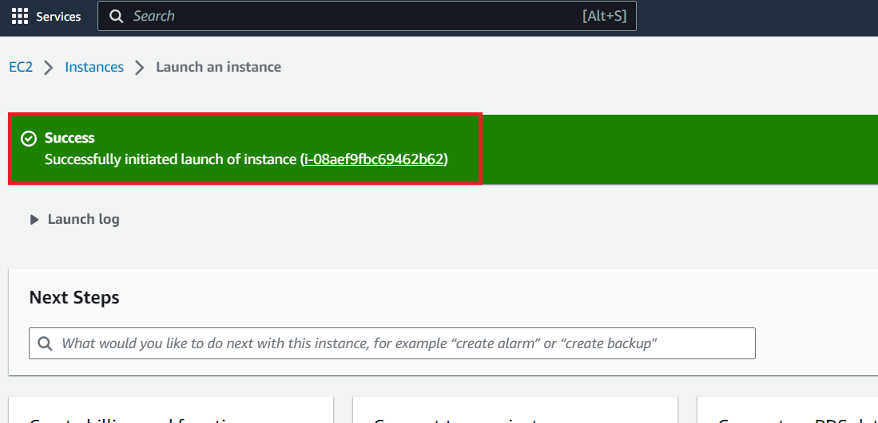

**Step 9: Click** on the **“Hyperlink”** of the **Instance Id.**

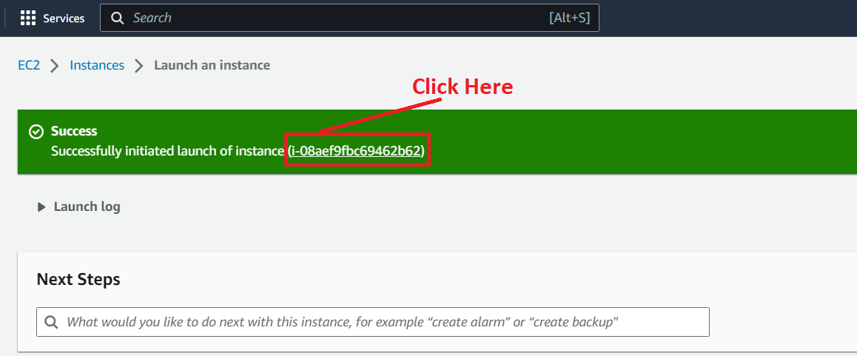

**Step 10: Your Instance** will be **shown** asin the **“Running”** state**.**

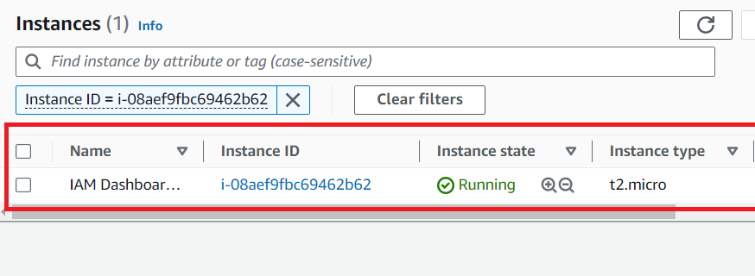

**2. Create a Dashboard for CPU Utilization & Network In**

**Step 1: Search** the **“CloudWatch”** in the “**Services”** Section. **Click** on the **“CloudWatch”.**

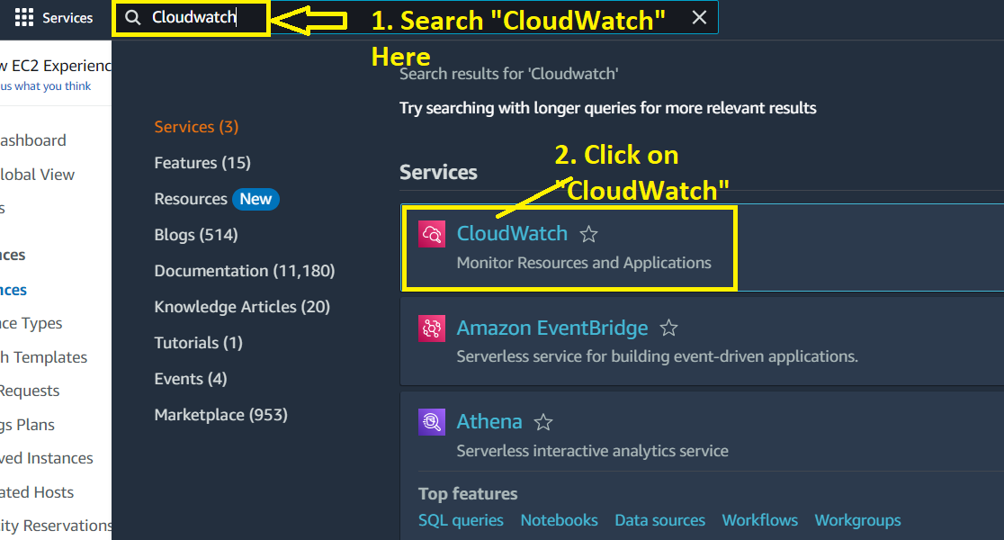

**Step 2: Go** to the **“Dashboards”.**

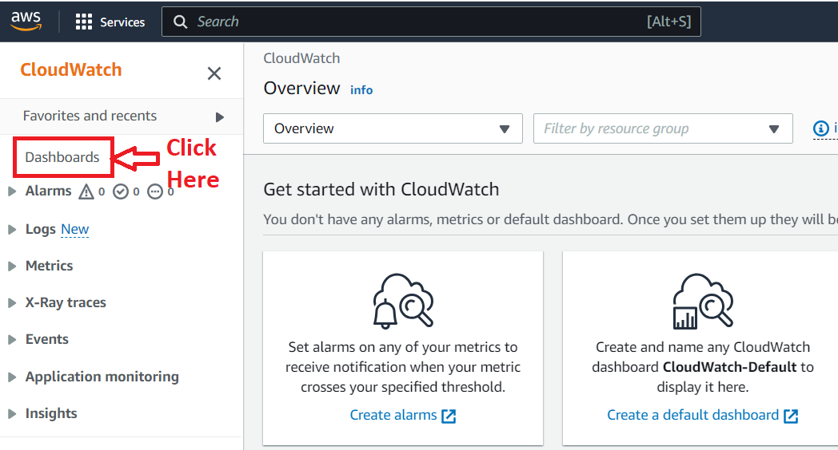

**Step 3: Click** onthe **“Create Dashboard”.**

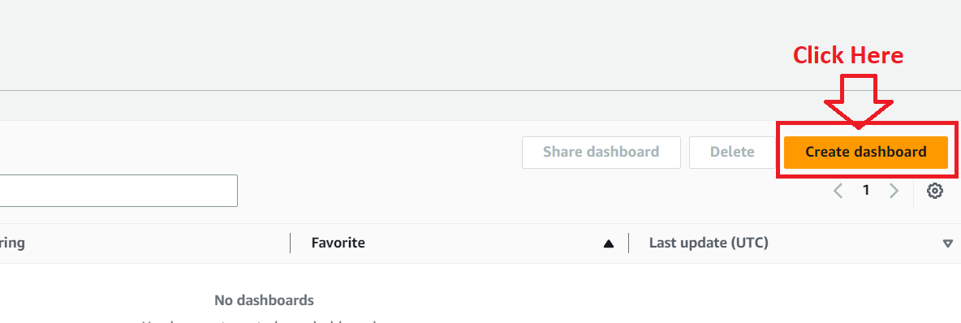

**Step 4: Choose** the **“Dashboard Name”** as the **“EC2_CPUUtilization_NetworkIn” & click** on the **“Create Dashboard”.**

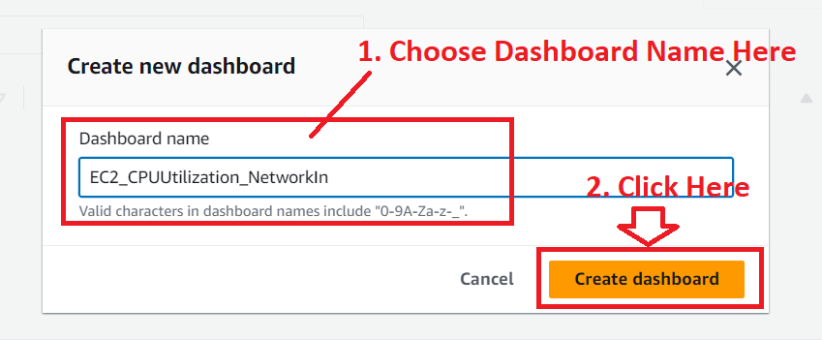

**Step 5: Your Dashboard** will be **successfully created & it** will **ask you** to **choose** the **metrics. Choose** the **“Line”** widget, **click** onthe **“Metrics>Next”.**

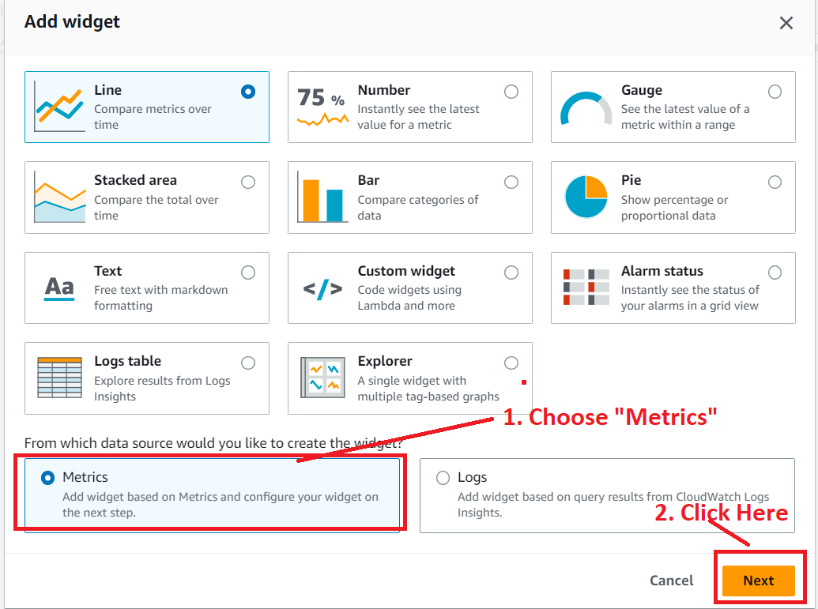

**Step 6: Select** the **“Metrics”** asthe **“EC2”.**

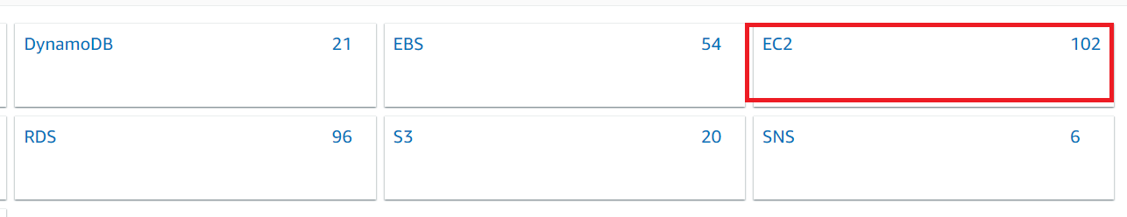

**Step 7: Click** on the **“Per Instance Metrics”.**

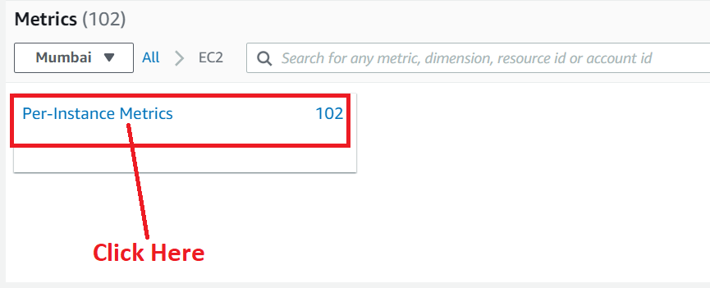

**Step 8: Select** the **“Metrics” as** the **“CPUUtilization” & “NetworkIn”. Click** on the **“Create widget”.**

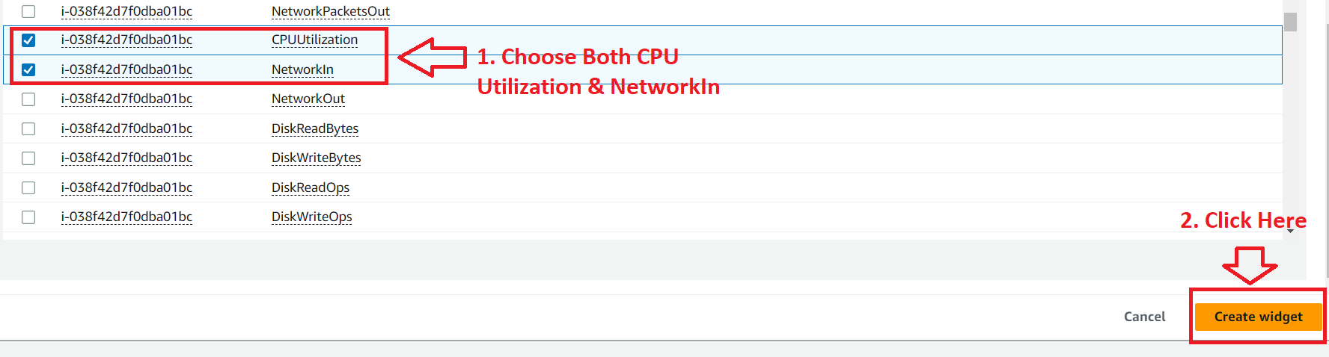

**Step 9: A dashboard (EC2_CPUUtilization_NetworkIn)** will be **successfully created.**

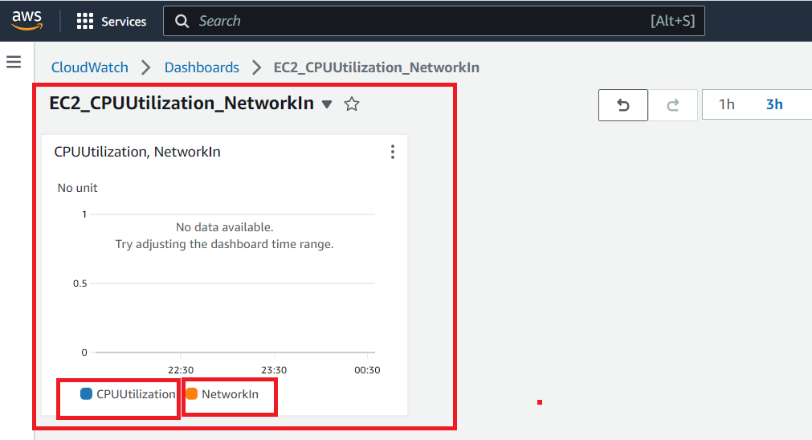

**Step 10: Click** on the **“Save”** button**.**

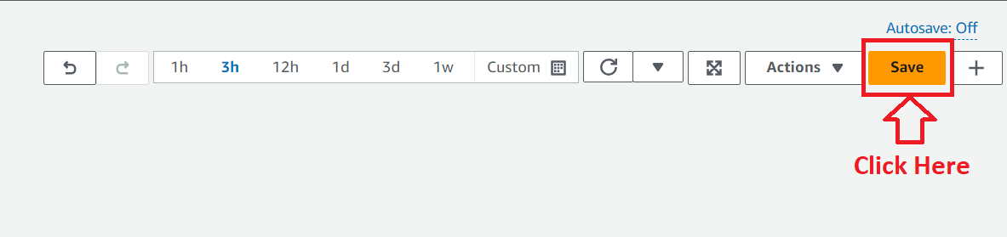

**Step 11: It will be saved successfully.**

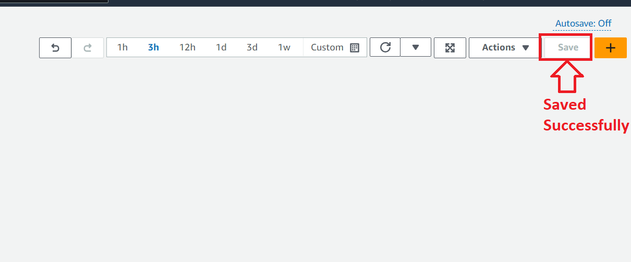

**3. Create Separate Alarm for CPU Utilization & Network In**

**a. CPU Utilization Alarm**

**Step 1: Go** to the **“Alarms>In alarms”.**

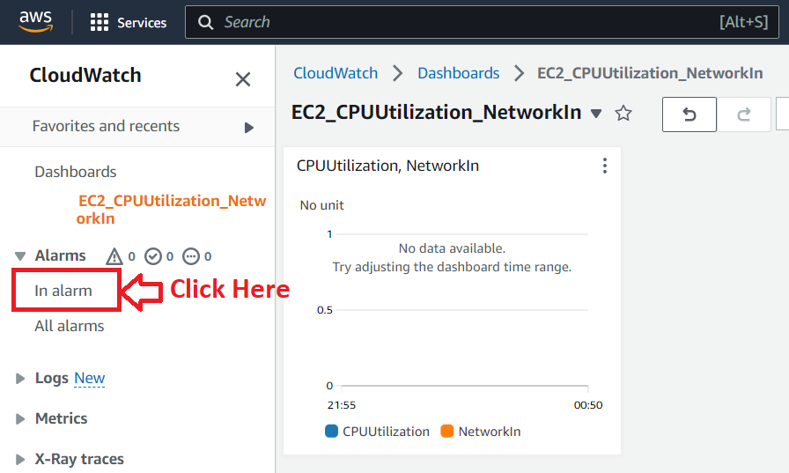

**Step 2: Click** on the **“Create Alarm”.**

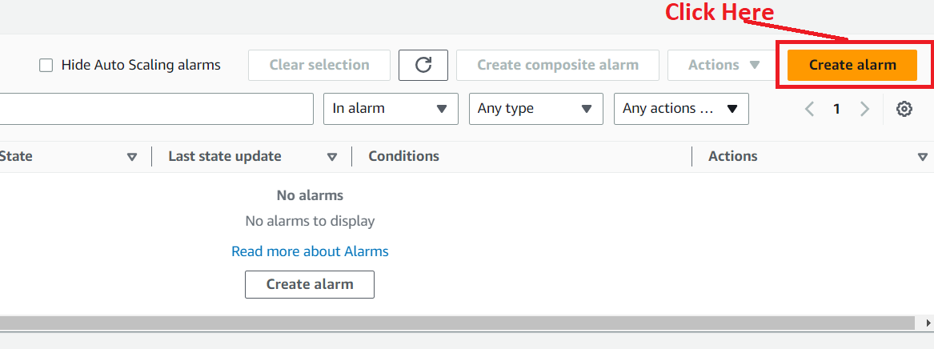

**Step 3: Click** on the **“Select metric”.**

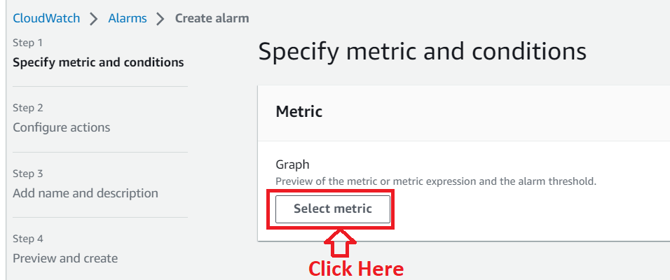

**Step 4: Select** the **Metrics** asthe **“EC2”.**



**Step 5: Click** on the **“Per Instance Metrics”.**



**Step 6: Select** the **“CPUUtilization” & click** on the **“Select metric”.**

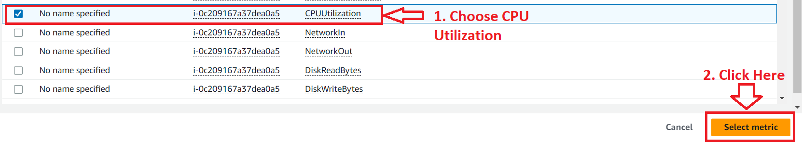

**Step 7: Paste** your **EC2 Instance ID** inthe **“InstanceId”** & **It** will **fetch** the **EC2 instance. Choose** the **“Period”** as **“1 Minute”.**

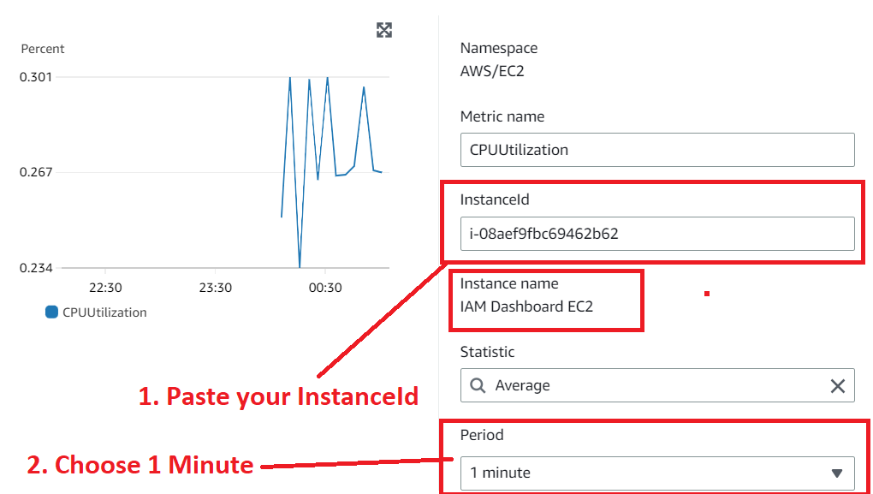

**Step 8: Choose** the **“CPUUtilization”** to **2%. Click** onthe **“Next”.**

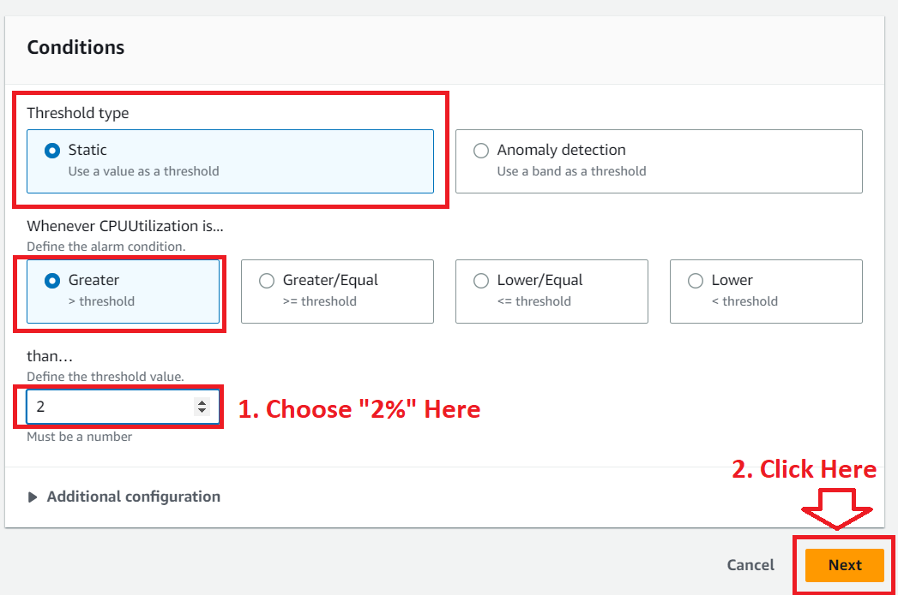

**Step 9: In** the **“EC2 Action”, Choose** the **“In alarm”** in the **“Alarm State Trigger”** section **& choose** the **actions** as the **“Stop This Instance”.**

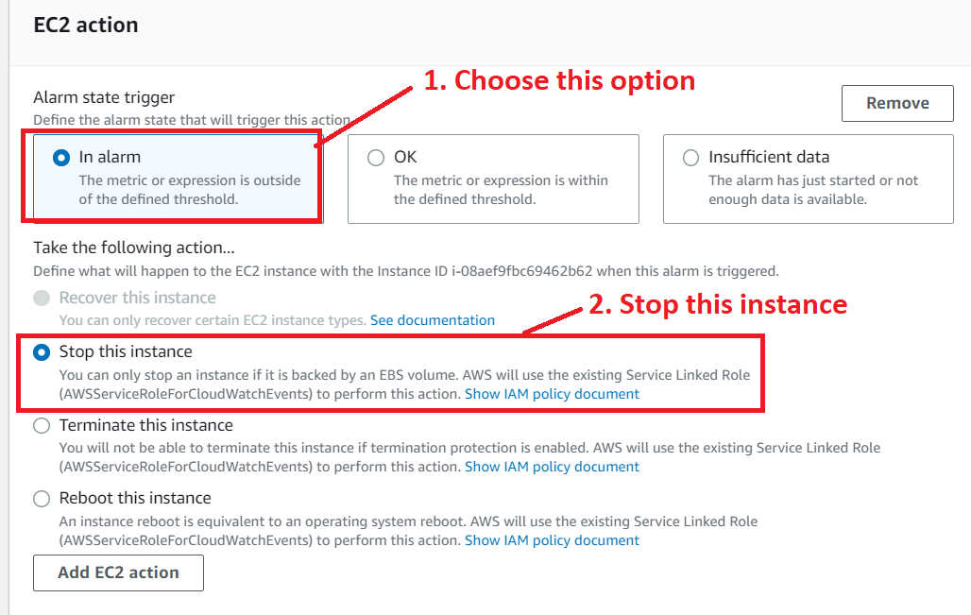

**Step 10: Click** on the **“Next”**

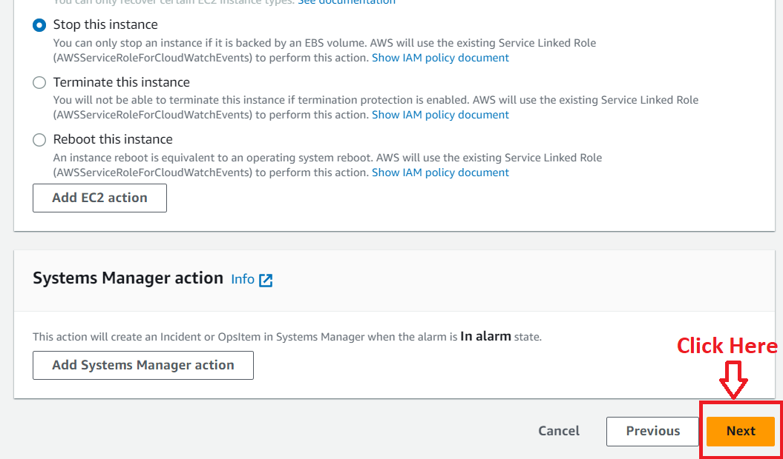

**Step 11: Choose** the **“Alarm Name”** asthe **“EC2_CPUUtilization”. Click** onthe **“Next”.**

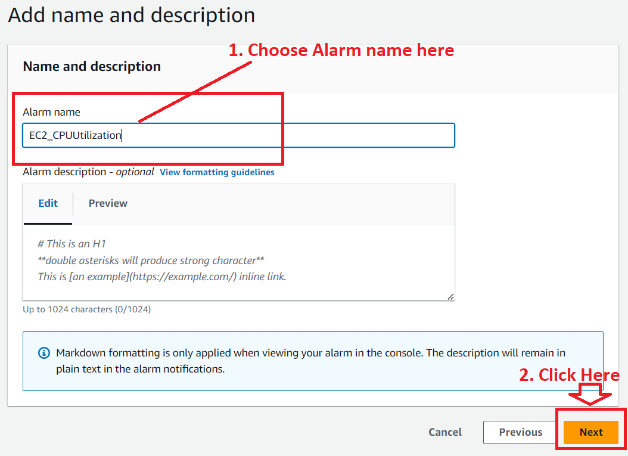

**Step 12: In** the **“Preview & Create”, click** onthe **“Create alarm”.**

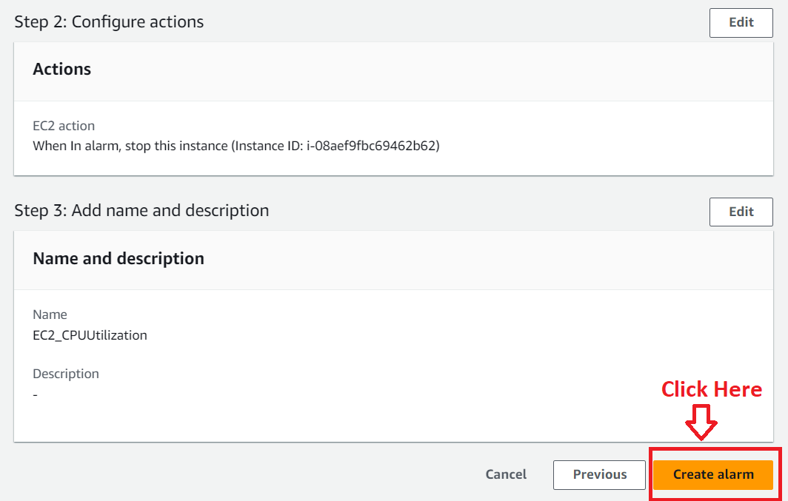

**Step 13: The “Alarm [EC2_CPUUtilization]”** will be **successfully created.**

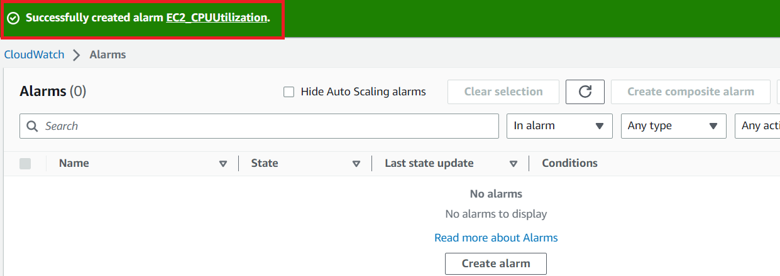

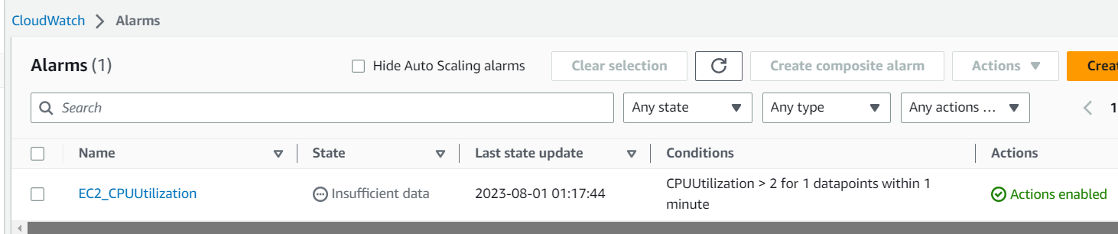

**b. Create the Networkin Alarm**

**Again, repeating the above steps;**

**Step 1: Click** on the **“Create Alarm”.**



**Step 2: Click** on the **“Select metric”.**



**Step 3: Choose** the **“Metrics”** as **“EC2”.**



**Step 4: Click** onthe **“Per Instance Metrics”.**



**Step 5: Select** the **“NetworkIn” metric** & **click** onthe **“Select metric”.**

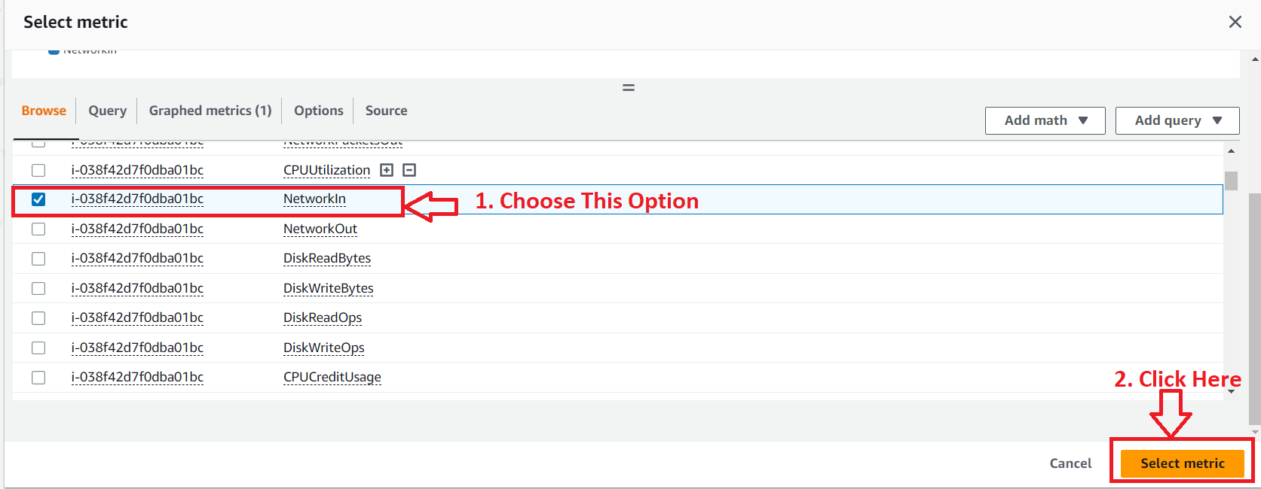

**Step 6: Paste** your **EC2 Instance ID** inthe **“InstanceId”** option **& It** will **fetch** the **EC2 instance. Choose** the **“Period”** as **“1 Minute”.**

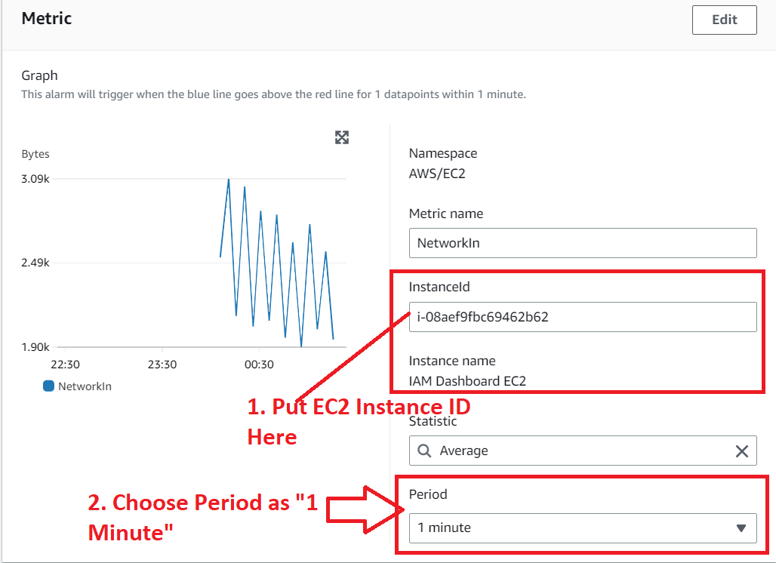

**Step 7: Choose** the **“Threshold type”** as **“Static”, NetworkIn** is **“greater than”** & **than is “2000 bytes”. Click** onthe **“Next”.**

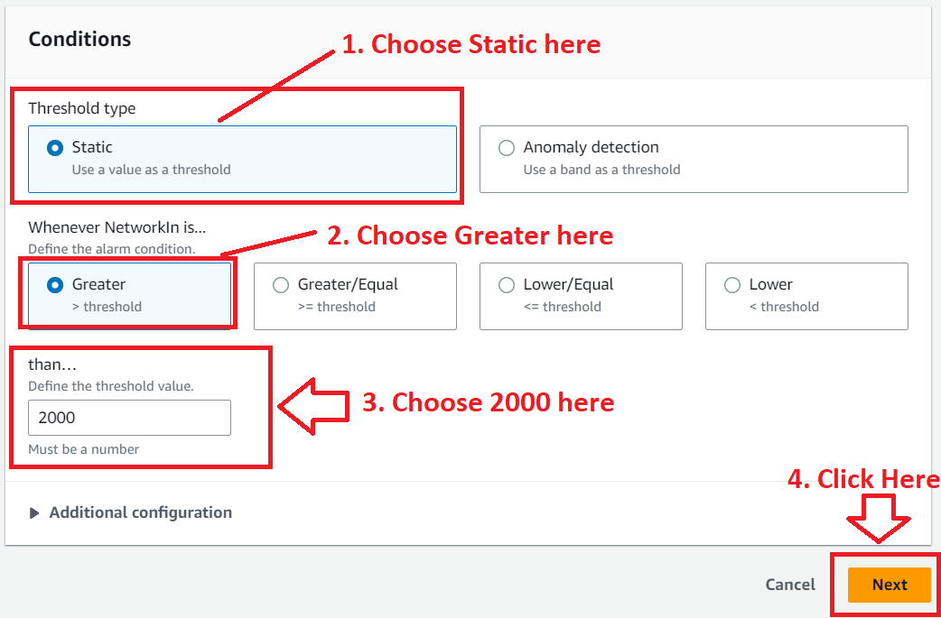

**Step 8: In** the **“EC2 Action”, click** onthe **“Add EC2Action”.**

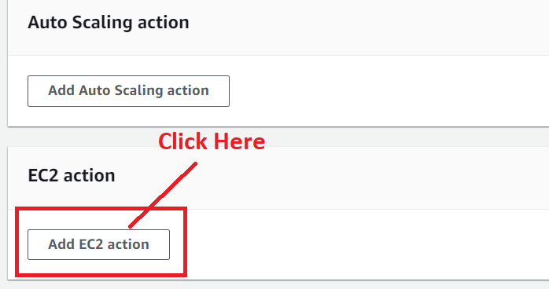

**Step 9: In** the **“EC2 Action”, Choose** the **“In alarm”** in the **“Alarm State Trigger”** & **choose** the **“Stop This Instance”** action.



**Step 10: Click** on the **“Next”**



**Step 11: Choose** the **“Alarm Name”** asthe **“EC2_NetworkIn”. Click** on the **“Next”.**

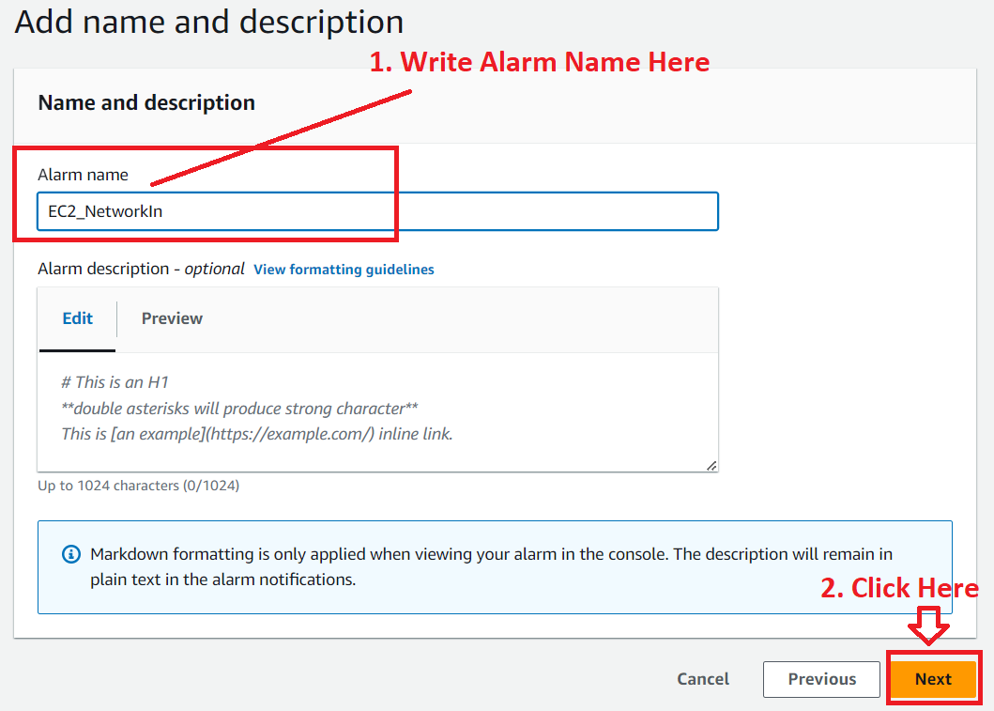

**Step 12: Click** on the **“Create Alarm”.**

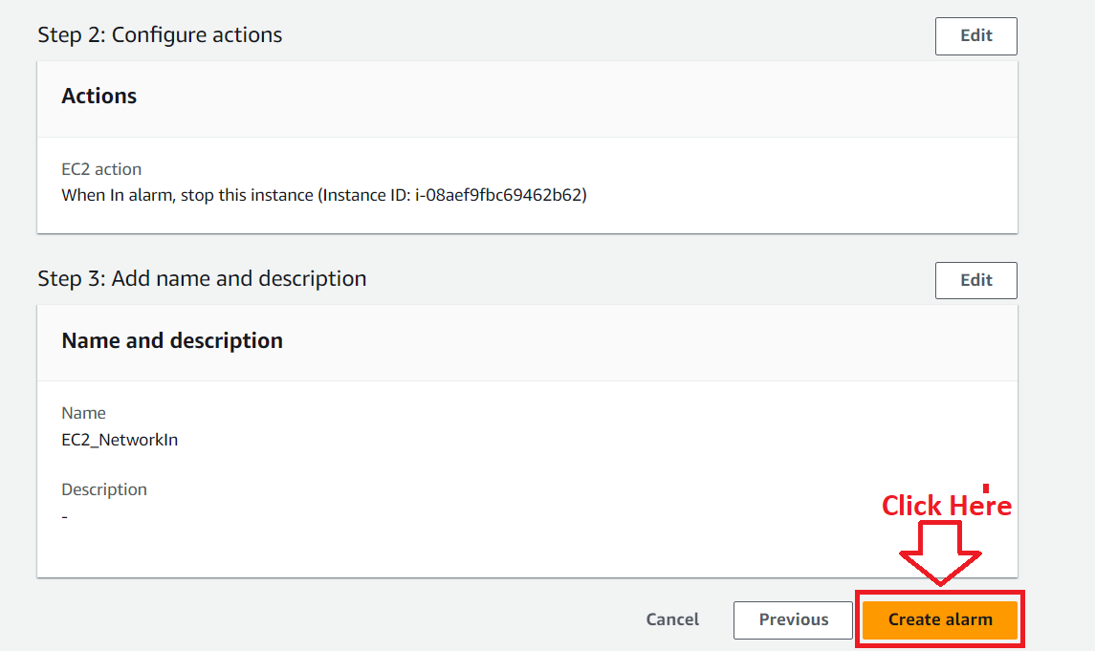

**Step 13: The “Alarm (EC2_NetworkIn)”** will be **successfully created.**

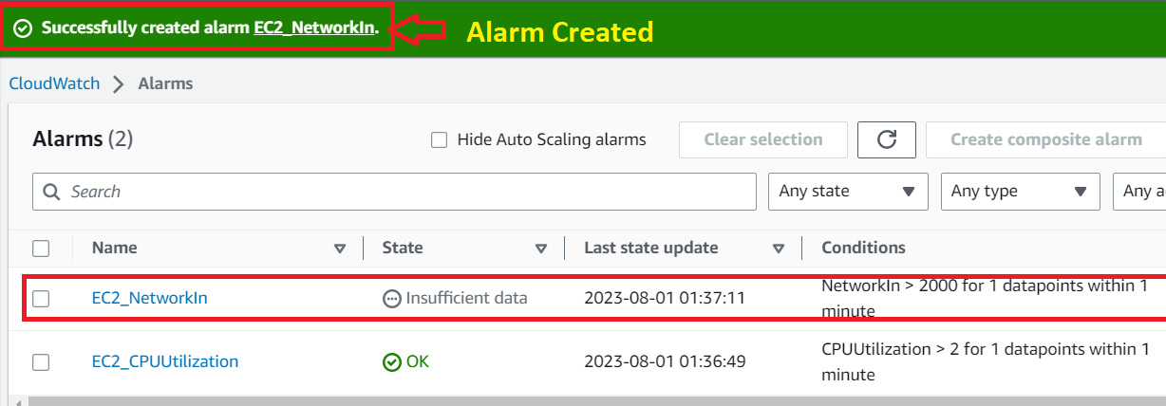

Now, we will test the EC2 Instance t o check the CPU Utilization & NetworkIn.

**4. Test the EC2 Instance to Check the CPU Utilization & Network In**

**Step 1: Go** to the **AWS Console. Click** on the **“EC2”.**

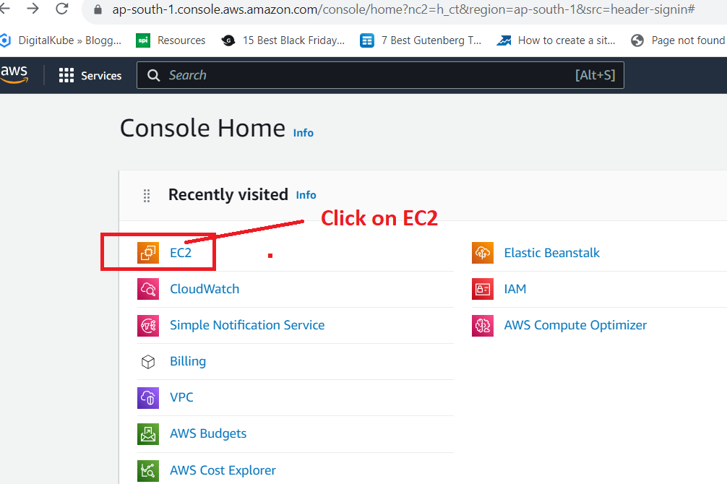

**Step 2: Click** onthe **“Instances (Running)”.**

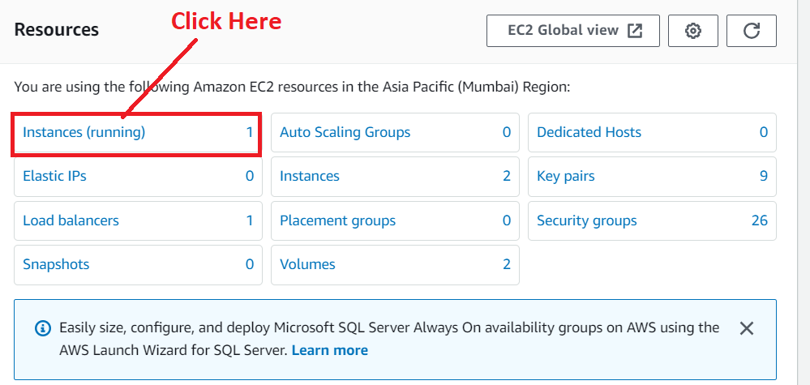

**Step 3: Select** your **EC2 Instance & Click** onthe **“Connect”.**

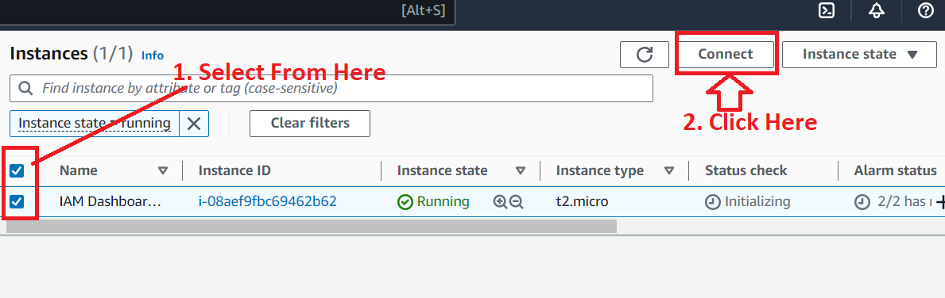

**Step 4: Again, click** on the **“Connect”**

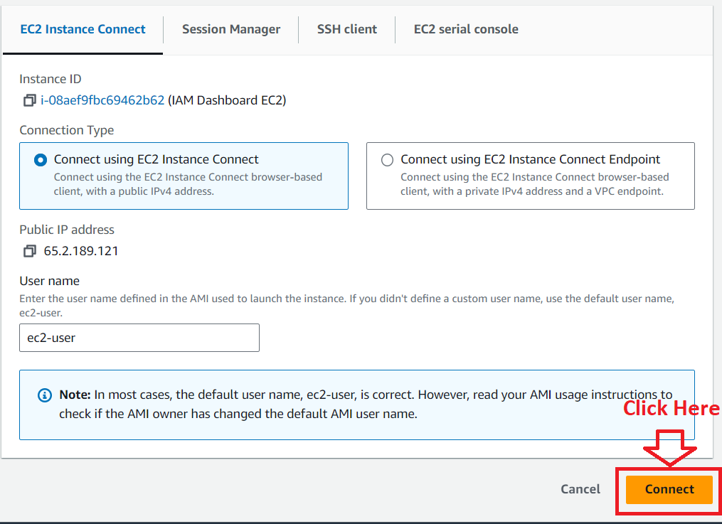

**Step 5: Your EC2 Instance** will be **successfully connected** & **you** can **perform** your **operation** through **EC2 Instance Connect.**

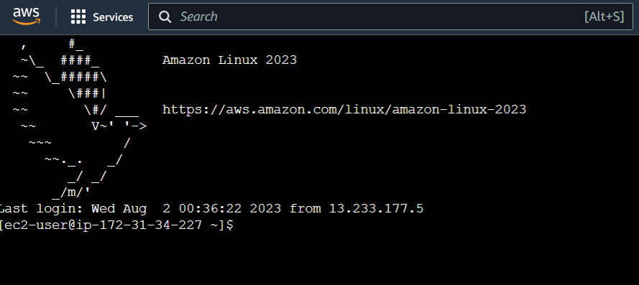

**Step 6: We** have **performed** the **certain operations** to **exhaust** the **alarm limit** & **the instance** has been **stopped** afterthe **execution.**

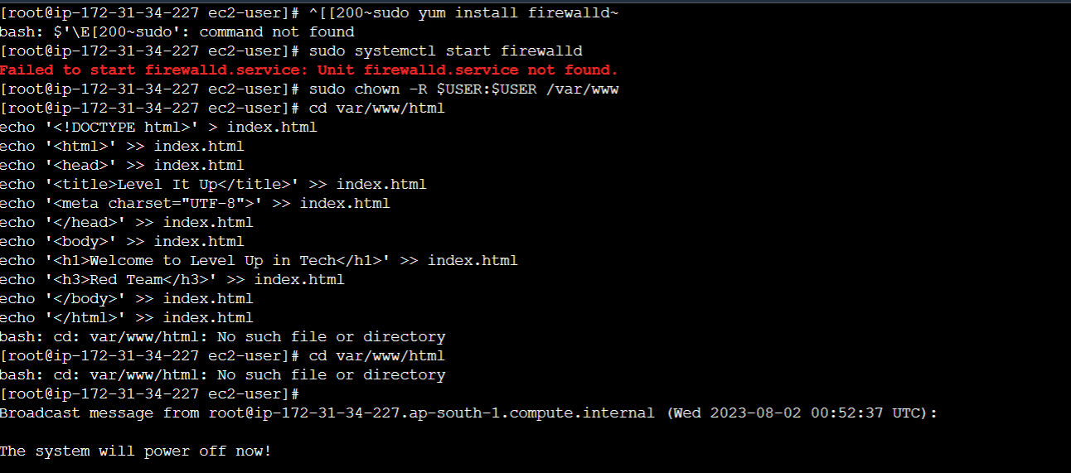

**Step 7: The “EC2”** will be **shown** as **2/2 Alarms** in the **“Red” sign.**

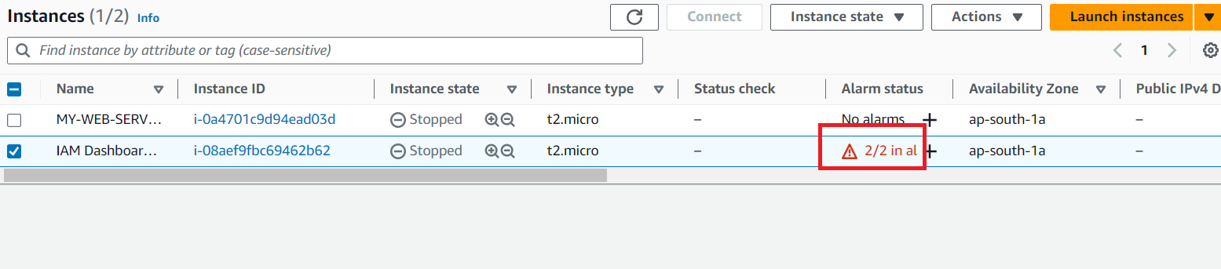

**Step 8: The “EC2 Alarms”** will **also** beas the **“In Alarm”** state.

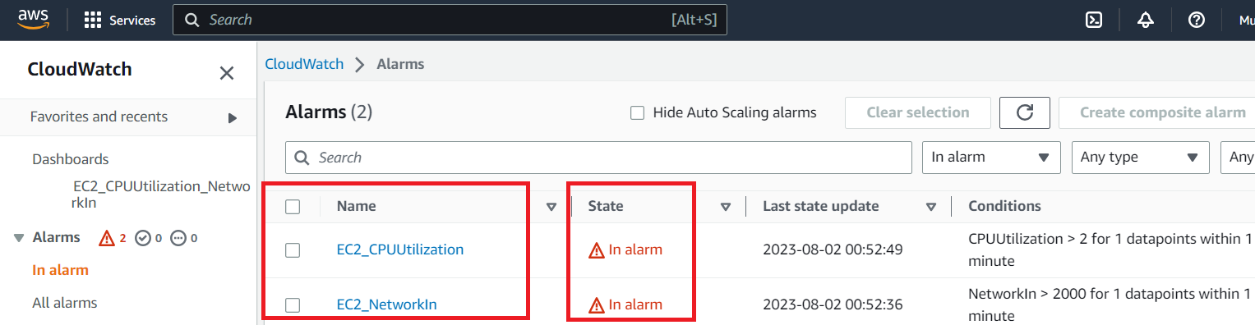

**Step 9: Your “EC2 CPU Utilization Dashboard”** will be **shown like this;**

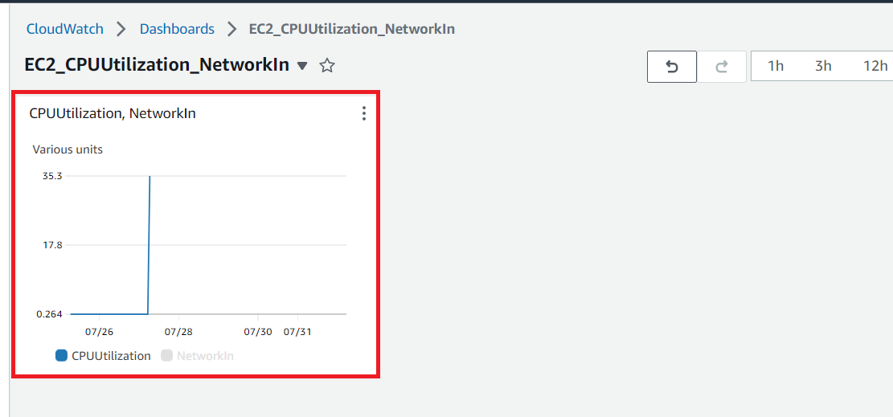

**Step 10: Your “EC2 NetworkIn Dashboard"** will be **shown like this;**

